Chapter 13, Problem 53.

Refer to the network in Fig. 13.118.

(a) Find n for maximum power supplied to the 200-Ω load.

(b) Determine the power in the 200-Ω load if n = 10.

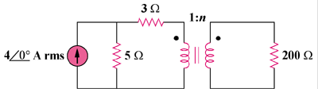

Figure 13.118
For Prob. 13.53.

